What Is Story?

You know what a story is, right? That’s easy. Movies, television, video games, novels, plays, even unstructured games as children. The hero defeats the villain; the girl gets her boy; people rise to great heights and experience tragic falls. Stories are entertainment.

They are. And…?

Where humans are we tell stories. Everywhere in the world at every time in human history in every known culture. Influential literary theorist Roland Barthes puts it this way: “Like life itself, [story] is there, international, transhistorical, transcultural” (237) Some archaeologists even believe a “cultural revolution” took place 40,000 years ago, catalyzed by development of language then used to tell stories.

Storytelling may have created us.

[Examples of ancient stories from the Aborigines of Australia, one of the oldest cultures on Earth]

Story, or narrative as it is called in academics, is so interwoven with the experience of being human we hardly recognize all the powerful ways it shapes us. Consider some of the most significant.

Story is:

A Mechanism for Making Meaning

It was rock bottom for me. No job. Just lost my scholarship. Even my dad was starting to agree with my wife about moving into her folks’ place, despite my protests I’d rather be shot in the face with a crossbow. Then it was like a miracle happened. I mean, it wasn’t a miracle, but it was like a miracle--I got appendicitis.

How do we know what something means, why it matters? By integrating it into a story. This typically isn’t an intentional, reasoned choice. It’s automatic and, likely, unavoidable.

Jonathon Adler, a professor of psychology at Olin College of Engineering, says, “The default mode of human cognition is a narrative mode” (qtd. in Beck). Stories are the predominant way in which humans think. They allow us to create meaning out of sensory perceptions, memories, information, conversations, symbols, and emotions that continually bombard us.

Consider if your friend just told you they were in a car accident. What questions would you ask?

What happened? (Plot)
Where did it happen? (Setting)
Whose fault was it? (Point of view and conflict)
Who was in the car? (Character)
Were you hurt? (Resolution)
Is your car going to be okay? (Stakes)

You ask questions that help you structure the event as a story so you know how to make sense of it. Without doing so, you simply don’t know what it means. Is your friend feeling foolish and guilty and looking for forgiveness, or are they furious and asking for validation that they’ve been wronged? I’d want to know the answer to this question before I responded with a friendship on the line.

A Genre and a Mode

The body was a body. So what? Splayed out, lieth looking and stiff, like many before, a pale imprint on asphalt. I was hungry and turned to leave. I immediately turned back, drawn by the body. Not the whole body, just the open eyes, blue as showroom tile.

Now that was interesting.

We traffic in story genres constantly. Nothing could be easier than telling the difference between a romantic comedy and a tragic drama at the movie theatre. Yet as different as story genres are, in important ways they are all the same. Those similarities make story a mode of thinking and communicating.

Mode means a particular method or way of doing something. Similar to how a computer has different modes, such as administrator, airplane, and safe, the brain has different modes of thinking. Likewise, language can be used in different modes to achieve different outcomes.

Because story is about meaning, not all sequences of events make a story. Take my six-year-old nephew, for example, who can spend an hour reciting everything he did last week on Minecraft.

“...and then I cut down another tree but then a creeper was there! This creeper starts chasing me, and I’m like, ‘Oh no!’ So I get away from the creeper and I’m walking all around and I find this lava flow. So, I’m like, ‘Cool!’ So then I go back home but on the way I see this cow so I start mining, and I go as deep as I can go, and then I find a diamond but when I get out the cow is gone. Then I see this big tree, so…”

At the end I dizzily realize I have no idea if any of that meant anything.

Young children often create “stories” that are really sequences without any greater meaning, such as kittens playing with a ball of string in cute and repetitious ways. This is a product of their developmental stage. Such sequences become functional stories in adolescence as the child’s brain develops the capacity to connect events in more complex and meaningful ways.

Cognitive storytelling requires that we pose questions about events either consciously or instinctively:

- When does an incident begin, what is its generation amidst other unconnected events that preceded it?
- What is its resolution?
- How do events in the interim relate to each other in relevant ways or, pointedly, not relate?
- What is at stake or, said another way, why does any of it matter?

Storytelling requires that we constantly analyze, synthesize, and evaluate our world, all while constructing ever-evolving patterns of meaning.

So what is the formula that makes a story? That’s a tricky question, one that theorists from a host of fields have debated for millennia and continue to do so to this day.

It’s a question complicated by how fluid and dynamic story structure is. For example, the structure adapts to the medium used to communicate it. A medium is something used to transmit to the human senses; it is often technological in nature, such as radio, television, the Internet, or even letters carved in stone (once the Ipad of its day).

Influential media theorist Marshal MacLuhan coined the phrase “the medium is the message” to convey how media affect the structure, and thus the meaning, of communication. An example is how texting encourages use of emojis to balance how short messages can feel curt or even angry.

Dun yet 😊

Yes 😕

No hurry

Story structure changes from episodic television episodes to two-hour films to dozens or even hundreds of still images in a comic book. Consider how different a television script for The Walking Dead is from a graphic novel version of the story.

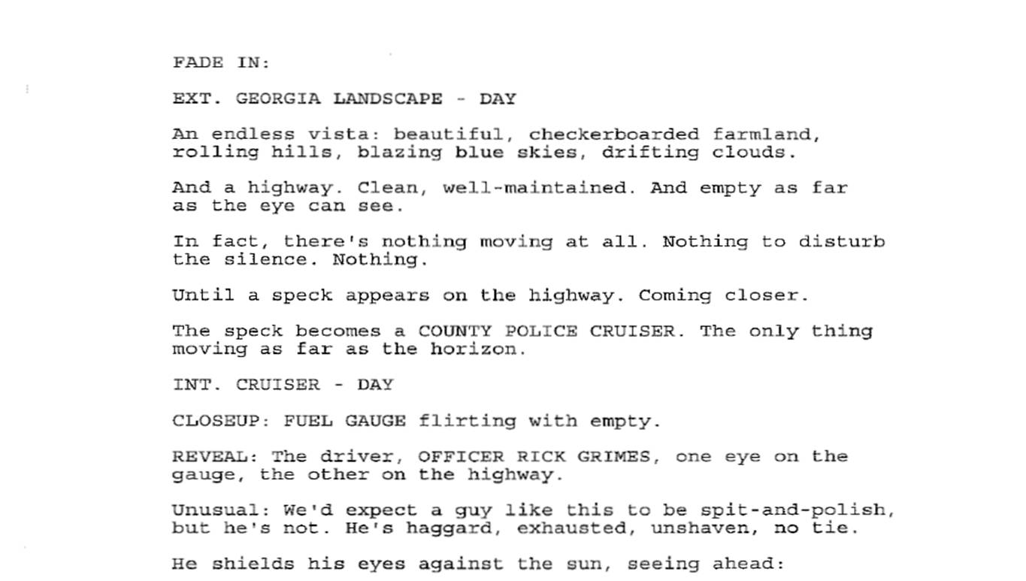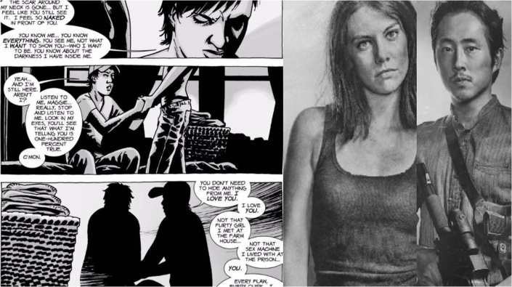

Despite these many structural differences--how words function with or in the absence of images, how time and place is established, the difference between a television scene or a comic cell or page--all story genres in all media use that storytelling mode we all recognize so well and understand so little. It’s what saves us from hours upon hours of Minecraft description.

Identity

Before Kristen was born, I wasn’t me. I mean, I was me, but I wasn’t this better version of me. My baby girl made me a good person.

Modern psychology considers that at least some, and perhaps all, of human identity is a story. I am the story I tell myself about what happens to me, so to speak. “The very idea of human identity—perhaps we can even say, the very possibility of human identity—is tied to the very notion of narrative and narrativity” (Brockmeier and Carbaugh 15).

Why is it that people who face the same traumas, such as combat, often respond in completely different ways? Science suggests that one reason, likely among many others, is because people respond differently to the same kind of event in their story of the self. A person who positions the event as a challenge to overcome in the story of a victorious life is far more likely to move beyond the trauma, or even use it as motivation for positive change. A spectrum of narrative therapies for trauma are now in common use for this reason.

[Learn about Narrative Exposure Therapy]

The stories we hear, whether in video games or history books or gossip over the neighbor’s fence, thus become a kind of menu where we can select stories to make meaning out of our experiences, giving us a sense of self.

[How Scout Finch from To Kill a Mockingbird Helped One Woman Become Herself]

As we now understand it, “People take the stories that surround them—fictional tales, news articles, apocryphal family anecdotes—then identify with them and borrow from them while fashioning their own self-conceptions. It’s a Mobius strip: Stories are life, life is stories” (Beck).

A Rhetorical Act

Khuma is seven, and he weighs thirty-seven pounds, roughly the weight of the average four year old. He looks bigger, but only in the middle, where his bloated belly is nearly round; his arms and legs are so spindly I find myself looking away whenever he walks the three and a half miles to the mission school. I doubt he can physically make the journey, every day, and every day he returns, weak from hunger but whole. Yet as he walks away the next day, I find I cannot watch, believing this is the day he will not return.

In one way or another, 3.1 million children like Khuma do not return home each year.

Stories don’t only shape how we see ourselves; they give us, every human, the power to shape each other, both individually and collectively. In effect, communicating a story to someone is a powerful act with the potential to produce change.

But not every story is powerful. Take my nephew’s Minecraft epic, for example. To have a legitimate chance of creating change, a story must be built with a specific audience in mind. The story must be rhetorical, meaning deliberately crafted by the storyteller in order to achieve a desired effect with a particular audience.

There is a misguided popular notion that stories, as expressive or emotionally rather than logically predicated, can never be either “wrong” or “right.” That to suggest a story may be ineffective is to tell the storyteller their feelings are invalid. In truth, shared stories are effective or not depending on an audience’s response to them, just as is true of an argument, or an evaluation, or a text sent to remind your significant other not to get that last brand of mayonnaise, which was disgusting.

Good storytelling requires apt rhetorical choices in creating the story. A storyteller “connects events into a sequence that is consequential for later action and for the meaning the [storyteller] wants [the audience] to take away from the story. Events perceived by the [storyteller] are selected, organized, connected, and evaluated as meaningful for a particular audience” (Reissman 3). Well-crafted, rhetorically-aware story provides unique ways to evoke feelings, sway thoughts, and motivate action.

Yes, stories are entertainment. But, like the story of Khuma above, they are also so much more that is much more important than a source of fun. Learning about stories—how to recognize them, different ways to read them, and how to write them—not only changes how you see the world, but who sees the world.

It changes others, and it changes you.

Works Cited

Barthes, Roland and Lionel Duisit. “An Introduction to the Structural Analysis of Narrative.” New Literary History 6.2 (Winter, 2008): 237-272. JSTOR. Web. 2 Feb. 2016.

Beck, Julie. “Life’s Stories.” The Atlantic, The Atlantic Monthly Group. 10 Aug. 2015. Web. 3 Feb. 2016.

Brockmeier, Jens and Donal Carbaugh. “Introduction.” In Jens Brockmeier and Donal Carbaugh (eds), Narrative and Identity: Studies in Autobiography, Self and Culture. Amsterdam: John Benjamins, 2001. Print. 1-22.

Riessman, C.K. Narrative Methods for the Human Sciences. Thousand Oaks, CA: Sage, 2008. Print.

